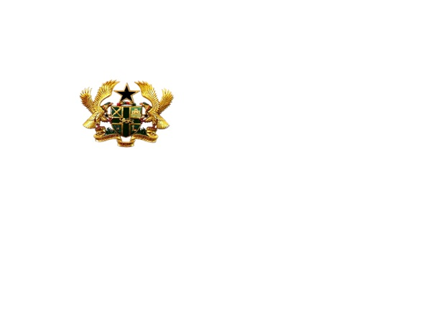**Atwima nwabiagya north district**



ME M O R A N D U M

**1STNOVEMBER, 2021**

**THE DISTRICT CHIEF EXECUTIVE**

**ATWIMA NWABIAGYA NORTH DISTRICT**

**BAREKESE**

**SUBMISSION OF REPORT ON NUTRITION ORIENTED PROGRAM FOR SCHOOL CATERERS AND FOOD VENDORS.**

I submit here with report on Nutrition orientation program for school caterers and food vendors for your study and action.

**………………………………**

**Abdul-Salam Abdulai**

**District Environmental Health Analyst**

**ATWIMA NWABIAGYA NORTH DISTRICT ASSEMBLY**

**ENVIRONMENTAL HEALTH AND SANITATION DEPARTMENT**

**REPORT ON NUTRITION ORIENTED PROGRAM FOR SCHOOL CATERERS AND FOOD VENDORS.**

In order to ensure that wholesome and nutritious food are served to school children, the Environmental Health and Sanitation Department of the Assembly organized a team up exercise to visit schools to educate caterers, kitchen staff and food vendors on nutritious food and the need to keep their surroundings clean.

This exercise started on Monday, 25th November, 2021 and ended on 29th November, 2021. The staff of the department visited some of the schools within the district. Some of the communities that benefited from this exercise include; Barekese, Akropong, Adankwame, Asuofua, Atwima Koforidua and Asamang.

Officers from the Unit educated the schools on proper nutritional practices to be ensured in their various schools and eating places and Proper nutrition for school children.

**OBJECTIVES**

* To do follow-up to the schools to ensure that the education given before was implemented.
* To educate caterers, kitchen staff and food vendors in schools on food hygiene

**RECOMMENDATIONS**

1. To enable the unit to monitor and control proper nutritional practices in schools, the assembly should help the unit with a vehicle to ease movement in the process.
2. The assembly should help the unit with mega phones to use in educating the public during their health education program/activities.

**CONCLUSION**

In conclusion, the above recommendations should be implemented by the district assembly to help improve our health education delivery.

**......................................................**

**ABDUL-SALAM ABDULAI**

**DIST.ENV’TAL HEALTH ANALYST**